Strategic Decision-Making using Power BI

Pre-Report Submission

Submitted to- Dr. ARPIT YADAV

Name: BISHAL KUMAR SHAW

Reg. No.: 2023JULB01220

Table Of Content

* Problem Statement ……………………………………………………………1
* Data Requirement ……………………………………………………………..2
* Data Collection …………………………………………………………………3
* Data Validation ………………………………………………………………….4
* Data Cleaning ……………………………………………………………………5
* Tools ………………………………………………………………………………..6
* Dashboard ………………………………………………………………………..7
* Storytelling ………………………………………………………………………..8

1. PROBLEM STATEMENT

The organization is experiencing **high employee turnover** and needs to better understand the factors contributing to this issue. Additionally, there is a need to analyse the **current employee demographics** to identify any trends, patterns, or disparities across departments, gender, salary, ethnicity, and satisfaction levels.

**Objective:**

1. **Employee Turnover Dashboard**:
   * Analyze **turnover rate** (33%) to determine key reasons behind employee exits.
   * Identify **trends by performance score**, satisfaction scores, salary ranges, and departments.
   * Highlight **voluntary vs involuntary turnover** and assess if specific genders, roles, or departments are disproportionately affected.
   * Provide insights to reduce turnover and improve retention strategies.
2. **Employee Demographics Dashboard**:
   * Analyze **current workforce composition** based on **gender, age, marital status, and ethnicity**.
   * Identify any **pay disparities** across ethnicities, genders, and departments.
   * Correlate department salaries with ethnicity to address inclusivity and fairness.
   * Ensure the workforce reflects diversity, equity, and inclusion (DEI) goals.

These dashboards aim to help HR and leadership teams make **data-driven decisions** to:

* **Improve employee retention** by addressing critical pain points.
* Promote **diversity, equity, and fairness** across all organizational levels.
* Enhance the organization’s ability to attract and retain top talent.

2. DATA REQUIREMENT

Provided dataset including details on orders, shipping, customer demographics, and financial performance.

**Columns Most Likely Used in a Dashboard**

For an **HR Dashboard**, the following columns would be most relevant:

1. **Department** (group-level analysis).
2. **Salary** (compensation insights).
3. **PerformanceScore** and **PerfScoreID** (employee performance analysis).
4. **EngagementSurvey** and **EmpSatisfaction** (employee engagement).
5. **Termd**, **DateofTermination**, and **TermReason** (attrition and turnover tracking).
6. **DateofHire** (tenure calculations).
7. **Absences** and **DaysLateLast30** (attendance metrics).
8. **RecruitmentSource** (effectiveness of hiring sources).
9. **GenderID**, **Sex**, **RaceDesc**, **MaritalDesc**, and **HispanicLatino** (diversity and inclusion insights).

3. DATA COLLECTION

**1. Employee Performance Analysis**

* **Relevant Columns**: PerformanceScore, PerfScoreID, EngagementSurvey, EmpSatisfaction, SpecialProjectsCount, LastPerformanceReview_Date
* **Objective**:
  + To assess employee performance and identify high-performing or underperforming employees.
  + Analyze factors influencing performance (e.g., satisfaction, engagement, workload).

**2. Attrition and Turnover Analysis**

* **Relevant Columns**: Termd, DateofTermination, TermReason, EmploymentStatus, Position, Department
* **Objective**:
  + Identify patterns and causes of employee turnover.
  + Measure turnover rates for departments, roles, or demographics.
  + Understand reasons for terminations and take preventive actions.

**3. Employee Engagement and Satisfaction**

* **Relevant Columns**: EngagementSurvey, EmpSatisfaction, Absences, DaysLateLast30
* **Objective**:
  + Assess employee satisfaction and engagement levels.
  + Analyze absenteeism and lateness as indicators of disengagement or dissatisfaction.

**4. Diversity, Equity, and Inclusion (DEI) Analysis**

* **Relevant Columns**: RaceDesc, Sex, GenderID, HispanicLatino, FromDiversityJobFairID, MaritalDesc
* **Objective**:
  + Analyze the diversity of the workforce (e.g., gender, race, ethnicity).
  + Measure the effectiveness of diversity hiring initiatives.
  + Ensure equal opportunities across demographic groups.

**5. Compensation and Financial Analysis**

* **Relevant Columns**: Salary, Department, Position, SpecialProjectsCount
* **Objective**:
  + Analyze salary distribution across departments and roles.
  + Ensure fair compensation practices and alignment with performance.
  + Track workforce costs and assess ROI on human capital.

**6. Recruitment Effectiveness**

* **Relevant Columns**: RecruitmentSource, FromDiversityJobFairID, DateofHire
* **Objective**:
  + Evaluate the performance of different recruitment channels.
  + Understand which recruitment sources yield long-term, high-performing employees.
  + Optimize recruitment strategies to reduce costs and improve quality of hire.

**7. Attendance and Productivity Analysis**

* **Relevant Columns**: DaysLateLast30, Absences, SpecialProjectsCount
* **Objective**:
  + Track attendance records and identify absenteeism trends.
  + Correlate productivity (e.g., projects completed) with attendance and lateness.
  + Improve attendance policies and identify potential issues affecting attendance.

**8. Demographic and Workforce Distribution**

* **Relevant Columns**: State, Zip, GenderID, RaceDesc, DOB, MaritalDesc
* **Objective**:
  + Understand workforce demographics (e.g., location, age, marital status).
  + Assess the distribution of employees across locations, departments, and roles.
  + Identify trends and patterns to aid workforce planning.

**9. Tenure and Retention Analysis**

* **Relevant Columns**: DateofHire, DOB, Termd
* **Objective**:
  + Analyze employee tenure and retention rates.
  + Identify which groups (e.g., roles, demographics) have shorter tenures.
  + Implement policies to improve retention.

**10. Managerial and Departmental Performance**

* **Relevant Columns**: ManagerName, ManagerID, Department, Position
* **Objective**:
  + Assess managerial impact on team performance, satisfaction, and turnover.
  + Compare performance and attrition metrics across departments.

**11. Strategic HR Planning**

* **Relevant Columns**: All columns
* **Objective**:
  + Provide holistic workforce insights to align HR strategies with organizational goals.
  + Optimize recruitment, retention, compensation, and diversity efforts.
  + Improve overall productivity, satisfaction, and engagement.

4. DATA VALIDATION

* **Data Cleaning Tools**: Excel formulas, filters, and functions are used to identify errors.
* **Automated Validation**: Tools like **SQL**, **Python (pandas)**, or **R** scripts can automate checks for duplicates, nulls, outliers, and consistency issues.
* **Manual Review**: HR teams validate unusual values or missing data flagged during automated checks.
* **Error Reporting**: Any anomalies or inconsistencies are logged for resolution.

5. DATA CLEANING

Handle Missing Data

Replace missing values or remove rows with essential missing data.

Correct Data Formats

Convert date fields to a uniform format (e.g., MM-DD-YYYY) and standardize text fields.

Filter Outliers

Remove unreasonable values in sales or profit fields.

Consolidate Data

Merge similar categories for streamlined analysis.

6. TOOLS

* MS-SQL
* PowerBI
* Power Query
* DAX Query

7. DASHBOARD

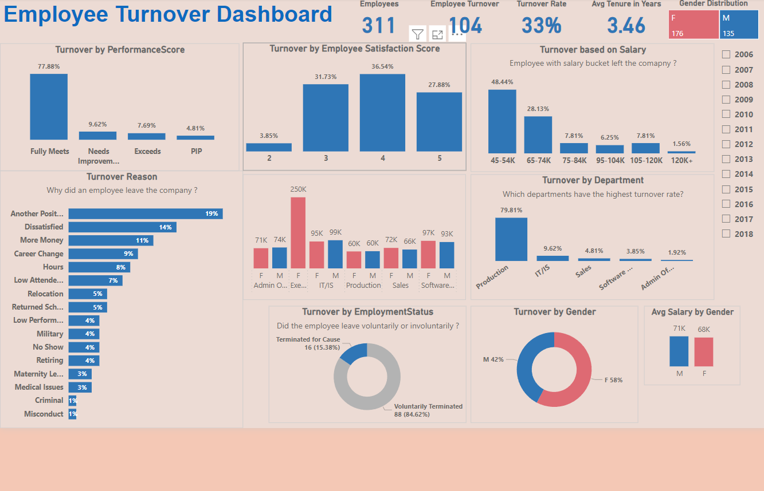

**Components of the Power BI Dashboard**

The dashboards collectively analyse:

1. **Workforce Composition**: Diversity, age, tenure.
2. **Performance**: Individual and departmental performance scores.
3. **Retention and Attrition**: Employee turnover and reasons.
4. **Compensation**: Salary, overtime, and bonuses.
5. **Employee Engagement**: Satisfaction surveys and attendance.

8. STORYTELLING

**Narrative: Workforce Overview and Strategic Insights**

**1. Workforce Composition and Diversity**

* *Insight*: The workforce is well-diversified, with a balanced representation across genders and races. However, certain departments show a skewed gender ratio (e.g., a higher percentage of male employees in technical roles and female employees in HR roles).
* *Actionable Decision*: Implement targeted recruitment campaigns to encourage diversity in underrepresented roles. Focus on diversity hiring in technology-driven departments.
* *Insight*: A significant percentage of employees are concentrated in the 25–35 age group, with fewer employees nearing retirement age.
* *Actionable Decision*: Leverage this youthful workforce for innovation while creating succession plans for critical roles occupied by older employees.

**2. Performance and Productivity**

* *Insight*: 80% of employees meet or exceed performance expectations. However, certain departments, like Customer Support, report a higher percentage of employees with "Needs Improvement" ratings.
* *Actionable Decision*: Introduce tailored training programs and mentorship initiatives for employees in underperforming departments. Evaluate workload distribution in these areas.
* *Insight*: Employees with high engagement survey scores consistently perform better. However, engagement scores are declining in teams with high absenteeism and overtime hours.
* *Actionable Decision*: Conduct one-on-one discussions to understand stressors and implement wellness initiatives. Optimize workloads and redistribute tasks in affected departments.

**3. Retention and Turnover**

* *Insight*: Employee turnover has increased by 15% this year, with "Voluntary Resignation" being the top reason. Analysis shows most resignations come from employees with 1–3 years of tenure.
* *Actionable Decision*: Strengthen onboarding and career development plans to engage new employees better. Introduce stay interviews to identify and address concerns early.
* *Insight*: Employees leaving the organization cite limited growth opportunities and uncompetitive salaries as primary reasons.
* *Actionable Decision*: Benchmark salaries against industry standards and develop clear career progression pathways. Highlight growth opportunities in internal communications.

**4. Absenteeism and Attendance**

* *Insight*: Absenteeism is higher in specific departments, such as Operations and Sales, which also have higher overtime hours. Employees with frequent absences show lower engagement and performance scores.
* *Actionable Decision*: Review shift scheduling and workloads in affected departments. Introduce flexible work policies and reward consistent attendance to improve morale.

**5. Recruitment and Onboarding**

* *Insight*: Most successful hires come from referrals and LinkedIn, while traditional channels like job fairs contribute fewer high-performing employees.
* *Actionable Decision*: Reallocate recruitment resources to focus on referrals and online professional platforms. Streamline the referral process and incentivize employees to refer high-quality candidates.
* *Insight*: Positions in specialized technical roles take longer to fill compared to others.
* *Actionable Decision*: Partner with niche recruitment firms or create internal training pipelines to upskill employees for these roles.

**6. Compensation and Rewards**

* *Insight*: Employees in lower pay grades report higher overtime hours but are less likely to receive bonuses. This correlates with lower engagement and higher turnover in these groups.
* *Actionable Decision*: Introduce overtime pay or incentives for employees in lower pay grades. Conduct periodic salary reviews to ensure fairness and competitiveness.
* *Insight*: Employees who participated in special projects and received bonuses are 30% more likely to exceed performance expectations.
* *Actionable Decision*: Expand opportunities for employees to contribute to special projects and establish transparent criteria for bonuses.

**7. Engagement and Satisfaction**

* *Insight*: Engagement scores are highest in departments with consistent leadership and frequent feedback loops. Departments with less engaged employees report irregular performance reviews.
* *Actionable Decision*: Mandate regular performance check-ins and leadership engagement across all departments. Provide managers with coaching on giving constructive feedback.

**Overarching Recommendations**

1. **Retention**: Prioritize efforts to reduce turnover by focusing on career development, employee engagement, and workload management.
2. **Performance**: Address low performance through targeted training and mentorship while recognizing and rewarding high-performing employees.
3. **Recruitment**: Streamline recruitment efforts by focusing on high-performing channels and addressing gaps in technical hiring.
4. **Compensation**: Revisit salary structures, especially for lower pay grades, and ensure incentives align with contributions.